

CSI Technical Journal
Volume XXIV, Number 3
March, 2006

In This Issue
More CSI Tools for Better Trading
Compatibility Corner: Trading Blox
Tech Talk
CSI Unaffected by NASDAQ Blunder
Conversion Factor Changes

More CSI Tools for Better Trading

The February issue of the CSI Technical Journal began a two-part series on CSI software and services that are useful to all subscribers, whether or not Unfair Advantage® is your primary trading tool. That issue included information on using the correlation studies found on the CSI website, which are a tremendous resource for understanding market direction and dynamics, and on the Trading System Performance Evaluator, which can help you assure that the system you are using is likely to turn a profit, given your funding and goals. We are in the process of expanding our correlation studies between markets to allow studying newly launched markets over time periods as short as one year. New markets regularly emerge, so there is no time like now to uncover the relationship between new market pairs that regularly surface.

This issue will delve further into CSI tools that can supplement any trading system by helping you screen signals and identify good prospective trades. The topics are: 1) Position Manager software, which lets you follow the daily or intraday progress of your trading account; 2) our Seasonal Index study, which lets you understand the long term seasonality of the market you plan to trade; 3) the Commitments of Traders (COT) database which lets you see if the commercial commitment sentiment supports your proposed trades and 4) an upcoming addition - The CSI Options Index which uses contrarian logic derived from put/call ratio data. Each of these is discussed below.

1) Position Manager

Unfair Advantage’s Position Manager software module shows your portfolio of holdings, complete with individual and full portfolio valuations on a daily or intraday (on demand) frequency. One of the interesting and unique features of this program is that you can display the valuations in dollars or any other currency of your choice. This product allows you to present your entry and exit price, the number of shares or contracts you hold and the direction (long or short) of your trade. You can also use it for paper trading to simulate transactions, and to follow the progress of the mutual funds you may have in your investment portfolio. Position Manager is quite helpful because it lets you see how your holdings are faring and how they react over time.

What’s paper trading?

Paper trading simply means that the recommended trades are recorded on paper (without any market risk) by writing down or electronically recording entry and exit prices, discounting for commission and slippage and accounting for the somewhat volatile conditions that are present when a trade is consummated. To properly account for the bid-ask bias that often faces a trader at the time of execution, one should adopt entry and exit prices on the unfavorable side of the bid vs. ask spread. Profit, loss and drawdown are calculated for each simulated trade and evaluated. Past performance, whether simulated or real, is no guarantee of future results. We urge our customers to take their time and get intimately familiar with any system of trading proposed to be followed.

A few caveats with regard to intraday updates: First, although Position Manager will give you an immediate assessment of the value of your holdings, subject to a 20-minute delay, the intraday quotes are not derived from CSI. They are collected from third-party websites that provide free delayed prices via the internet. These intraday valuations are not screened by CSI for accuracy, so you should consult your broker before acting on any data received. Second, because the third-party websites are not affiliated with CSI, they could forbid access by your computer at any time. It is unlikely that this will happen if you use intraday updates sparingly; however, very frequent updates or very large portfolios may be considered excessive and will eventually result in the banning of your computer’s IP address from their websites. Failing to heed this warning may require that you purchase a new computer to resume service. Position Manager’s capabilities fit well with the needs of the average investor following a typical portfolio, but may not be suitable for large-scale endeavors.

2) Seasonal Index:

Most commodity markets exhibit strong tendencies to follow inherent seasonal forces. Here at CSI we fashioned a seasonal waveform for every individual commodity market representing cumulative price behavior over time. The wave form is normalized such that price extremes are apparent for both high and low market levels. Many commodities show seasonal tendencies in their behavior, and our Seasonal Index gives the trader a chance to see what directional behavior might be likely in the days to come for those seasonally affected commodities. When past seasonal forces suggest a rising or falling market over the immediate future, consider aligning your trades to agree with past seasonal behavior which is displayed and projected forward in time from the last trading day shown.

The chart at left demonstrates how the seasonal waveform corresponds with long-term price activity and with the recent prices of the seasonal market Heating Oil (CSI #89 - HO). As you can see in this chart showing Perpetual Contract® data, the Seasonal Index’s oscillating blue wave form tends to lead the market. Although it is calculated on decades of Perpetual Contract data, its peaks and troughs are near the peaks and troughs of recent contracts. The Seasonal Index projects higher prices for Heating Oil in the summer months, but these projections may or may not come to fruition in any given year. They merely reflect the historical tendencies of this market over time. The Seasonal Index is a useful piece of information, revealing meaningful market cycles. It makes no attempt to provide a definitive trading signal. It may not be immediately obvious from the chart shown, but if you look closely at the cumulative blue line waveform you will notice that the seasonal wave form changes slightly as each new day of actual experience is factored into the results. The dynamics of a market’s seasonal behavior changes slightly as more information is supplied.

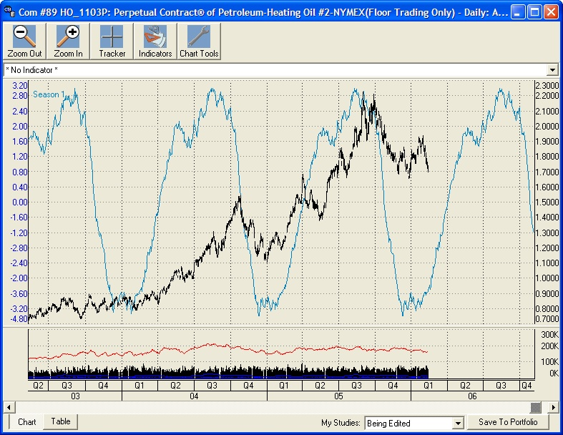
CSI’s Seasonal Index for Heating Oil (oscillating blue line), plus Perpetual Contract data for Heating Oil.

3) Commitments of Traders (COT) Data

Returning to the concept introduced last month of using specialized data to understand market dynamics and enhance trading success, this recommendation for all traders is to study Commitments of Traders (COT) data. I suggest CSI’s COT study because this data lets you keep tabs on the market interests of larger traders and hedgers. These are the market movers and shakers whose activities typically influence future price performance.

How do you use the COT data?

Simple: all positions in your account should be aligned with the weekly directional movement of commercial interests. If your trading software suggests a position that bucks commercial interests, think twice (or maybe three times) before entering that trade - and don’t forget a closely placed protective stop!

COT statistics, which are compiled by the CFTC, are available to CSI customers through Unfair Advantage, and also to the general public from our source, Steve Briese’s Bullish Review. Our data set includes Briese's computed COT Index, as well as the CFTC's raw released information. These bi-weekly reports are available every Tuesday with any corrections for the earlier week and the new government computed statistics on alternating Tuesdays. We advise all CSI customers to consult the Bullish Review for more information and insightful commentary.

Commitments of Traders data and the Briese COT Index are found in Unfair Advantage’s “Miscellaneous" database, where you can select them for charting or export. The Briese Commitments of Traders Index can also be displayed as a study on the UA chart of the corresponding commodity's price series, as shown here.

4) CSI’s Option Index (soon to be released)

The CSI Options Index is an original CSI product that uses option data to measure the relationship between puts, calls and ratios for a given option and then interprets trading sentiment from that relationship. This study is based on the well-known tendency of the put/call ratio to be a contrarian indicator. Please note that the CSI Options Index is available only to CSI customers who subscribe to the options database. (No other daily data service carries an options feed.) Although this data set can increase your monthly expenditure on data, it should more than pay for itself with the first successful trade it helps you find.

Since we are writing about making money in the markets with products produced by others, you may have noticed that we rarely get into the more or less invalid theory suggesting that price today determines price tomorrow. Many trading systems do just that. There are cases where under certain circumstances this premise may be true, but such systems can only work well when the dynamics of the markets make it possible. Currencies are just about the only reliable market where price in the past might predict price in the future. This is true because governments are slow to adopt changes in their monetary policy. They do this by affecting the interest rates they allow banks to charge. This is why you will sometimes witness long trends in certain currencies. A country’s central bank accomplishes this for traders, but believe me, it isn’t intentional. Many traders take advantage of this anomaly.

Supplement the trading advice you may have garnered from a compatible CSI software vendor by employing the above important CSI tools. You may avoid some mistakes, and be better advised in your trading in the process. If you have questions or need help in using CSI tools, please give us a call. Our success strongly depends upon keeping our customers profitable.

Bob Pelletier

For more information on the COT data series and their uses, consider
subscribing to Steve Briese's Bullish Review, an invaluable service that is
very helpful when trading all regulated U.S. futures markets. Every two
weeks Steve reports on dozens of government-regulated commodity markets,
supported by charts and commentary. Please tell Steve you were referred by CSI.

Phone: 888-423-4950
www.insidercapital.com

#####

Compatibility Corner: Trading Blox

We at CSI are pleased to be among the preferred data vendors for many third-party investment programs. Compatibility Corner is an occasional series that introduces our customers to programs that run on quality CSI data. The following was provided by the makers of Trading Blox* to introduce their CSI-compatible program.

Trading Blox™ is a software platform on which you can run commercial or public domain systems, or develop your own system. It will help you backtest the system through a comprehensive set of simulations, including stepping the start date and duration of the test, changing the portfolio composition, adjusting commission/slippage/equity, and stepping all user adjustable parameters your system contains.

Trading Blox™ software allows you to thoroughly examine the performance of trading systems under a variety of different market conditions so you can better understand the performance characteristics of a trading system before you begin trading. If the system is Robust, the simulation results will reflect this. These good results will give you the confidence to consistently apply the rules of your automated strategy during adverse market conditions. If your system is not Robust, you have the opportunity to improve it before putting your money on the line. The end result is a Robust system, with which you can have confidence!

Trading Blox 2.0 is now available at www.tradingblox.com or 617-933-9096.

*Not a CSI product. CSI does not endorse or stand behind the products of outside firms.

#####

Tech Talk

Each month in this column the CSI Technical Support staff addresses topics of interest to many CSI subscribers. This month they will discuss just one topic: Candlestick charting in UA.

Q. I’m interested in exploring alternative forms of chart analysis. Is it possible to view Candlestick Charts with Unfair Advantage? Also, where can I learn about using Candlestick Charts?

A. Unfair Advantage will let you into the world of “Spinning Tops,” “Doji Lines” and more through our Candlestick Charting feature. Although the original presentation of prices is in Open, High, Low, Close bar charts, you can select Candlestick Charts though the charting Right-Click menu. Get there by creating a chart and then clicking the right (not left) mouse button. Select “Display Bars As” from the menu to bring up additional choices. As you’ll see, from there you can choose from “Close Only,” “HLC” (high, low, close) “OHLC” (open, high, low, close) or “Candlestick” charts.

Our manual gives a brief description of how Candlestick charts are formed and the general implications of black and white candlesticks, but we refer you to the expert, Steve Nison, CMT for an in-depth information on the complex chart interpretations. Check out his website at http://www.candlecharts.com or see his book, Japanese Candlestick Charting Techniques, Revised Edition; Prentice Hall, Inc., 2001.

Q. The Candlestick charts I display with Unfair Advantage are colorful (either red or green), as opposed to the black and white candlestick charts I have studied. This makes it difficult for me to interpret which bars are “dark“ (shaded) and which are “white“ (not shaded). Is there a way to change the presentation of candlesticks?

A. Absolutely. You can adjust the color of any field on your UA charting screen, including the various components of Candlestick charts. From your Candlestick chart, bring up the right-click menu by clicking the right mouse button and then choose, “Change Color Scheme.” Click the “Candlestick Up Fill” field and then change the color to white. This will make non-shaded “White Candlesticks” that correspond with the traditional presentation. All of your subsequent charts will retain this presentation until such time as you change or “reset” the selection.

Q. When I convert my bar chart into a Candlestick chart, the daily bars are so close together that I can’t make out the formations. How can I get a better view?

A. Use the “Zoom In” tool (it looks like a magnifying glass with a plus (+) symbol) on your charting toolbar to focus in on detailed candlestick groupings. When you find a comfortable bar spacing for your analysis, you might want to arrange for it to be the default presentation. To do this, click your right mouse button and then select “Save Current Zoom Level.” The Default Zoom Level can also be set through UA’s Charting Preferences.

###

CSI Unaffected by NASDAQ Blunder

You may have heard in the national news that NASDAQ released incorrect information on a massive set of securities on January 19th, which resulted in inaccurate data around the world. CSI customers were among the few who were not affected, thanks to the unique method we use in compiling daily summary prices. Those massive errors were neither captured by our system nor delivered to CSI customers.

####

Conversion Factor Changes
Beginning on February 13, 2006 the CBT changed the quoting method for 10 Year Interest rate swap futures (CSI #678 and CSI #679) from 32nds to 32nds and halves. CSI now quotes this as 64ths, the same way FV #251 is quoted. This allows the 32nds and halves to be accurately represented while maintaining maximum software compatibility.
Beginning on February 15, 2006 the SFE changed the quoting method for Three Year Bonds (CSI #231 and CSI #615) from 2 decimal places to 3. CSI now quotes this to 3 decimal places.
CSI customers started seeing expanded precision on February 14th for all four series.

Unfair Advantage users saw their conversion factors change automatically, but will need to collect new history for 231, 615, 678, and 679.
History adjusted for the conversion factor change is available in CSV and fixed text format upon request.

